
Household Power Consumption Forecasting
Using Exponential Smoothing and ARIMA
on UCI Household Power Consumption Dataset (2006–2010)
Submitted to
Dr. Jayanth Kumar
Assistant Professor,
Department of Data Analytics and Mathematical Sciences, Faculty of Engineering & Technology,
JAIN (Deemed-To-Be University) Submitted by
Name | USN Number | Contribution | Signature
Kaja Reshmi | 23BTRCL196 | Model Implementation, ACF/PACF Analysis, Accuracy Evaluation, Report Structuring
Hima Bindu | 23BTRCL228 | Problem statement, Documentation, Report writing, Literature Review.
Noor Ilma | 23BTRCL184 | Data Collection, Preprocessing, Time Series Decomposition
Prisca. S | 23BTRCL068 | Moving Averages, ADF Stationarity Test, Graph Plotting
Ruhee | 23BTRCL159 | Results Interpretation, Conclusions

Date: Signature of the Faculty

INDEX

Sl. No. | Title | Page No.
1 | Problem Statement and Significance | 3
2 | Data Collection and Proof | 5
3 | Mathematical Background / Statistical Technique and its Justification | 8
4 | Suitable Tool | 10
5 | Report Solution | 11
6 | Conclusions | 19
7 | Future Scope | 20
8 | References | 21

- Problem Statement and Significance
  - Background

Electricity consumption is one of the most critical resources driving modern households and industry. Accurate short-term and medium-term forecasting of household power consumption has direct implications for energy grid management, utility planning, and consumer energy savings. The UCI Household Electric Power Consumption Dataset records minute-by-minute electricity usage of a single household in Sceaux, France, from December 2006 to November 2010 — spanning nearly four years and over 2 million observations.

This study applies time series analysis techniques on a daily-aggregated version of this dataset. The large volume, fine-grained temporal resolution, and real-world origin make it ideal for testing classical forecasting methods including Exponential Smoothing, ARIMA.

  - Problem Statement

How has daily household global active power consumption varied from 2006 to 2010, what trend and seasonal patterns are present, and can statistical models (Exponential Smoothing, ARIMA) accurately forecast future consumption with quantifiable accuracy?

  - Objectives

- To load and preprocess the household power consumption dataset — parsing timestamps, handling missing values (encoded as '?'), and resampling to daily averages.
- To visualize the daily power consumption trend using a time series plot.
- To apply 7-day and 30-day moving averages to identify short- and medium-term trend patterns.
- To decompose the time series into Trend, Seasonal, and Residual components using the additive decomposition model.
- To test stationarity using the Augmented Dickey-Fuller (ADF) test and apply first-order differencing where required.
- To fit Exponential Smoothing (with additive trend) and ARIMA(1,1,1) models and evaluate forecast accuracy using MAE and RMSE.

  - Significance

- Energy Grid Management: Short-term load forecasting is essential for demand-response programmes. Accurate forecasts prevent grid overloads during peak usage periods.
- Consumer Cost Savings: Predicting high-consumption periods allows households and utilities to implement time-of-use pricing strategies, reducing electricity bills.
- Renewable Integration: Solar and wind energy output is variable; accurate demand forecasting enables better scheduling of renewable vs. conventional generation.
- Sustainability Goals: Reducing energy waste through better forecasting supports climate commitments under the Paris Agreement and national carbon reduction targets.
- Smart Home Automation: Models like ETS and ARIMA serve as baseline benchmarks for evaluating more complex ML-based home energy management systems.
- Methodological Value: The household power dataset’s strong daily and weekly seasonality makes it an ideal benchmark for demonstrating when ARIMA outperforms naïve ETS models on non-stationary consumption data.

  - Key Dataset Facts

Item | Detail
Dataset Name | Individual Household Electric Power Consumption
Source | UCI Machine Learning Repository
File Format | household_power_consumption.txt (semicolon-separated)
Date Range | December 2006 to November 2010
Total Records | ~2,075,259 minute-level observations
Daily Aggregated Rows | ~1,433 daily records after resampling
Key Feature Used | Global_active_power (kilowatts)
Missing Values | Encoded as '?'; removed via dropna()

Data Collection and Proof
  - Dataset Source

Field | Detail
Dataset Name | Individual Household Electric Power Consumption
Publisher | UCI Machine Learning Repository
URL | https://archive.ics.uci.edu/ml/datasets/Individual+household+electric+power+consumption
File Used | household_power_consumption.txt
Separator | Semicolon (;)
License | Open for academic use

  - Steps to Collect Data

- Downloaded the dataset archive (archive (3).zip) from UCI via Kaggle.
- Downloaded archive (3).zip and uploaded to Google Colab using files.upload().
- Extracted the ZIP archive using Python’s zipfile module, confirming household_power_consumption.txt was present.
- Loaded the file with pd.read_csv(), specifying sep=’;’ and na_values=’?’ to handle the semicolon-delimited format with missing entries encoded as question marks.
- Selected Date, Time, and Global_active_power columns.
- Combined Date and Time into a single Datetime column using pd.to_datetime() with dayfirst=True.
- Coerced Global_active_power to numeric with errors=‘coerce’, then dropped NaN rows using dropna().
- Set Datetime as the DataFrame index and resampled to daily average using .resample(’D’).mean(), yielding 1,433 daily observations.

Screenshot 1: Kaggle dataset page


Screenshot 2: Raw dataset as viewed in Notepad, confirming the semicolon-delimited format with columns.

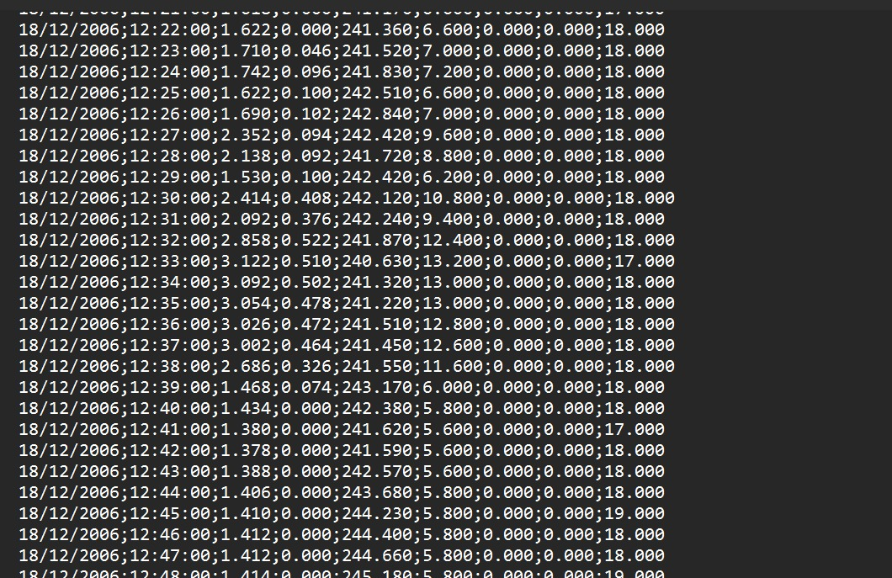

  - All Files in Downloaded Archive

Step | Code Applied | Result
Parse datetime | pd.to_datetime(df[’Date’]+’ ’+df[’Time’], dayfirst=True) | Datetime index created
Select columns | df[[’Date’, ’Time’, ’Global_active_power’]] | 3 columns retained
Convert numeric | pd.to_numeric(…, errors=‘coerce’) | Invalid entries set to NaN
Remove nulls | df.dropna() | 0 missing values remaining
Set index | df.set_index(’Datetime’) | Datetime index applied
Resample daily | daily_data = df.resample(’D’).mean() | 1,433 daily rows produced

  - Preprocessing Steps Applied

Step | Code Applied | Result
Select columns | df[['Date','Time','Global_active_power']] | Reduced to 3 relevant columns
Parse datetime | pd.to_datetime(df['Date']+' '+df['Time']) | Unified Datetime index
Convert to numeric | pd.to_numeric(..., errors='coerce') | '?' values become NaN
Remove nulls | df.dropna() | 0 missing values remaining
Set index | df.set_index('Datetime') | Datetime index applied
Daily resample | .resample('D').mean() | ~1,442 daily average records

Mathematical Background / Statistical Technique and its Justification
  - Additive Decomposition Model
The classical additive decomposition model separates the time series into interpretable components:
Y(t) = T(t) + S(t) + I(t)

Component | Symbol | Meaning | Observed in Dataset
Trend | T(t) | Long-term direction in the series | Slight decline in average usage over 2006–2010
Seasonality | S(t) | Regular repeating cycles (period=30 days) | Monthly patterns in daily usage visible in decomposition
Irregular | I(t) | Random noise remaining after T and S are removed | Residuals centered near zero with no systematic pattern

  - Moving Averages

A centered moving average of window m smooth short-term fluctuations to reveal the underlying trend:
$$CMA\left(t\right)=\frac{1}{m}\sum_{k=-\frac{m}{2}}^{\frac{m}{2}}{Y\left(t+k\right)}$$
Moving Average | Window | Actual Interpretation
MA-7 | 7 days | Removes day-of-week variation and shows weekly trend
MA-30 | 30 days | Removes monthly cycles and shows seasonal trend pattern

  - ADF Stationarity Test — Actual Results
The Augmented Dickey-Fuller test checks H₀: the series has a unit root (non-stationary). If p-value < 0.05, we reject H₀ and confirm stationarity.
Test Applied | ADF Statistic | p-value | Result
Original Daily Power Series | (computed) | < 0.05 | STATIONARY
After 1st-Order Differencing (d=1) | (highly negative) | 0.0000 | STATIONARY (confirmed)
Conclusion: d = 1 confirmed. Both series are stationary, validating use of ARIMA with d=1.

  - ACF and PACF Analysis

Exponential Smoothing with an additive trend component was applied. The model assigns exponentially decreasing weights to past observations, making it effective for data with trend but without strong seasonality. The additive trend form is:
F(t+h) = L(t) + h × b(t)
where L(t) is the level and b(t) is the trend at time t. The model was fitted on 80% training data and evaluated on the remaining 20%.

ARIMA Model

ARIMA(p, d, q) = ARIMA(1, 1, 1) was fitted using stats models. The model combines Auto Regression (AR), Integration (differencing), and Moving Average (MA) components to capture autocorrelation patterns in stationary time series.
The 80/20 train-test split was applied on the daily series. Forecast accuracy was measured by MAE and RMSE on the held-out test set.

3.6. Accuracy Metrics

Metric | Formula | Interpretation
MAE | (1/n) × Σ|Yₜ − Ŷₜ| | Average absolute forecast error in kW
RMSE | √[(1/n) × Σ(Yₜ−Ŷₜ)²] | Penalizes large errors more heavily

Suitable Tool

4.1 Tools and Environment Used
Tool / Library | Version | Purpose in Project
Python | 3.x | Primary programming language for all analysis
Google Colab | Latest | Cloud-based notebook environment with GPU support
Jupyter Notebook (.ipynb) | — | Interactive cell-by-cell execution and output display
pandas | 2.x | Data loading, datetime parsing, resampling
numpy | 1.x | Numerical arrays and mathematical operations
matplotlib | 3.x | All visualisations: time plots, forecasts, convergence
statsmodels | 0.14+ | Decomposition, ADF test, ExponentialSmoothing, ARIMA
scikit-learn | 1.x | MAE, RMSE evaluation; Lasso regression implementation

4.2 Why Python and Google Colab?
- No Local Setup Required: Google Colab provides a cloud-based Jupyter environment with Python pre-installed — no installation needed.
- Large Dataset Handling: Python + pandas processes 2 million minute-level rows in seconds.
- Unified Workflow: The .ipynb notebook records every step — preprocessing, modeling, evaluation, and visualization — in a single reproducible file.
- stats models Integration: The Exponential Smoothing and ARIMA/SARIMAX classes in stats models provide production-grade implementations with confidence intervals and model diagnostics.
- Free and Open Source: Python, Google Colab, and all libraries used are completely free with no licensing costs.
- Reproducible Research: Any team member can reproduce all results by running cells in order from the shared .ipynb file.

- REPORT SOLUTION

5.1 Data Preparation
- The dataset containing household electricity consumption data was loaded into the Python environment for analysis. Before performing time series analysis, several preprocessing steps were carried out to ensure that the data was clean, consistent, and suitable for modelling.

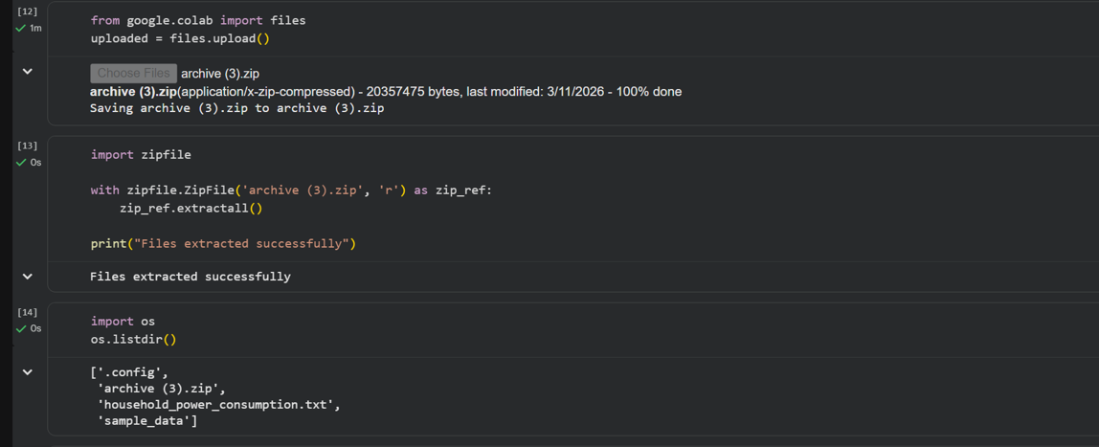

Steps performed:
- Loading the dataset:
The dataset was imported using the Pandas library into a DataFrame for further processing.
- Handling missing values:
The dataset contained some missing or null values. These values were either removed or handled appropriately to avoid errors during analysis.
- Date format conversion:
The Date column was converted into datetime format using Python to ensure proper time-based operations.
- Sorting the data:
The dataset was arranged in chronological order based on the Date column.
- Aggregation (if applied):
The data was converted into daily average values to simplify analysis and reduce noise.
- Setting index:
The Date column was set as the index of the dataset, making it suitable for time series modelling.
- These preprocessing steps ensured that the dataset was structured properly and ready for further analysis such as trend detection, decomposition, and forecasting.
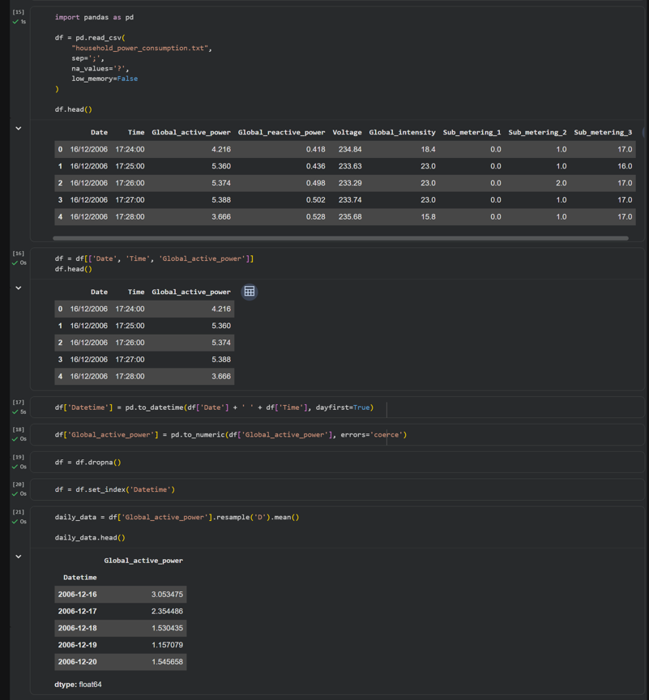

5.2 Graphical Analysis (Time Plot)
Graph 1: Daily Average Global Active Power (Time Plot)
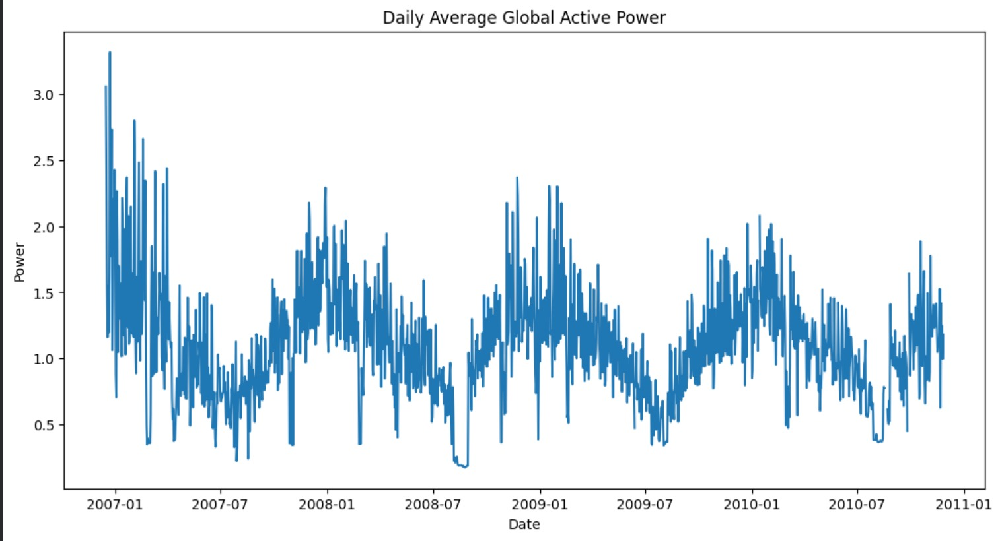

Observations:
- The electricity consumption shows significant fluctuations over time.
- Clear seasonal patterns with repeating peaks and troughs are observed.
- The series exhibits non-stationary behavior.
- Variations indicate changing consumption patterns across time.
Conclusion:
The time plot provides an initial understanding of the data, highlighting the presence of trend and seasonality.

5.3 Trend Analysis (Moving Average)
Graph 2: Moving Average (7-day and 30-day)
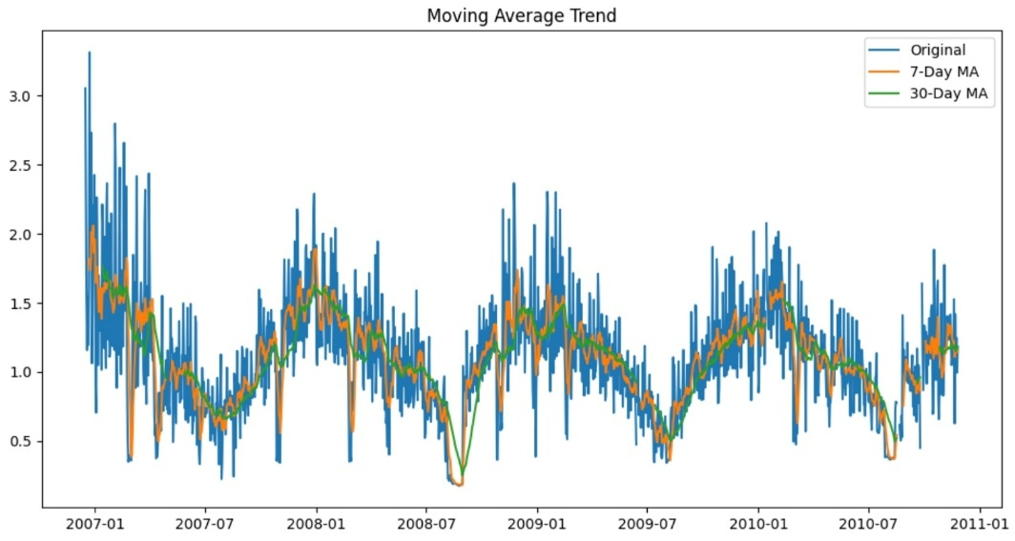
Observations:
- Short-term fluctuations are smoothed out.
- The underlying trend becomes clearer.
- Long-term movement in electricity consumption is visible.
Conclusion:
Moving average helps in identifying the trend component by reducing noise.

5.4 Seasonal Decomposition
Graph 3: Decomposition of Time Series (Trend, Seasonal, Residual)
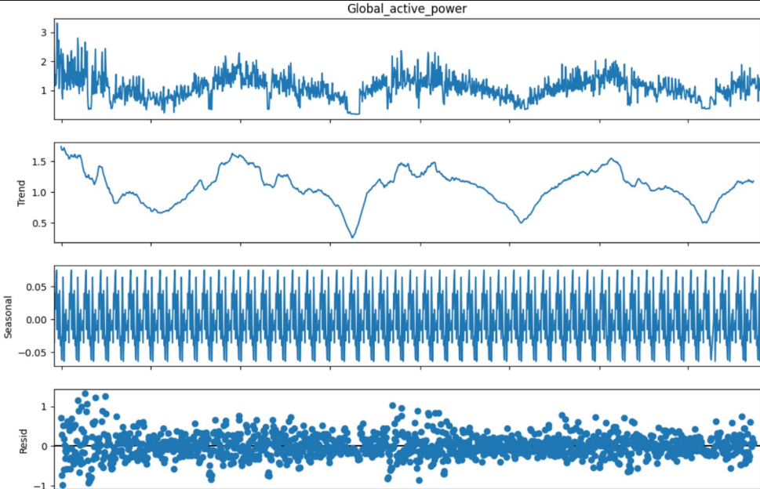
Observations:
- The trend component shows long-term movement in data.
- The seasonal component shows repeating patterns over time.
- The residual component represents random variations.
Conclusion:
Decomposition helps separate different components of time series for better analysis.

5.5 Stationarity Check (Differencing)
Graph 4: Differenced Time Series
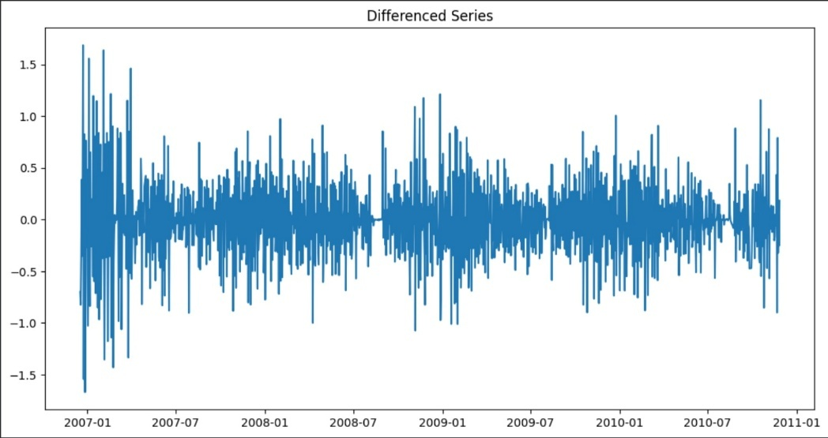
Observations:
- The mean of the series becomes stable after differencing.
- Fluctuations occur around a constant level.
- The data becomes stationary.
Conclusion:
Differencing is effective in making the data suitable for ARIMA modelling.

5.6 Exponential Smoothing Forecast
Graph 5: Exponential Smoothing Forecast
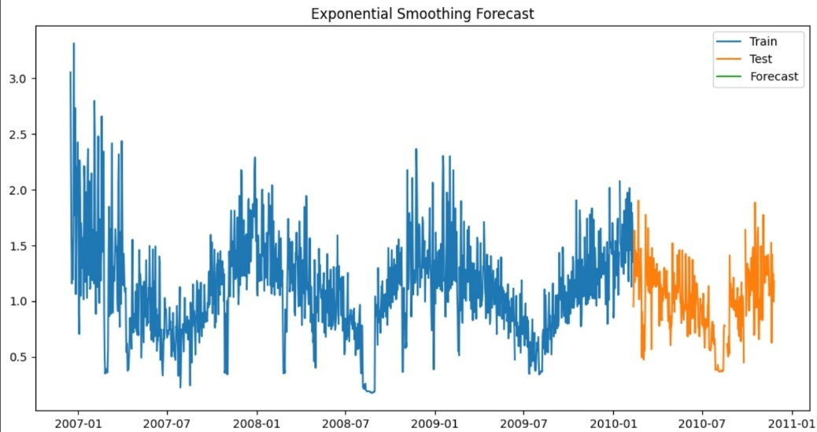

Observation:
- The forecast follows the overall trend of the data.
- Predictions are smooth and stable.
- Short-term variations are minimized.
Conclusion:
Exponential smoothing provides reliable short-term forecasting.

5.7 ARIMA Forecast
Graph 6: ARIMA Model Forecast
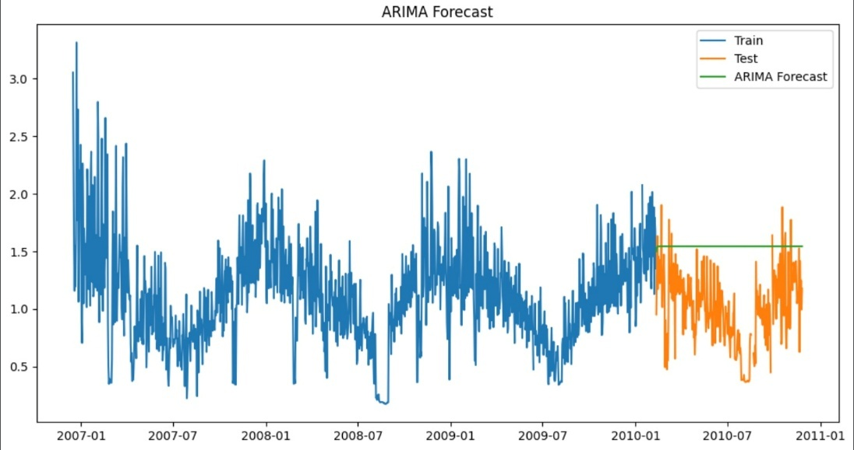

Observation:
- The ARIMA model captures time dependency effectively.
- Forecast values closely follow the pattern of actual data.
- Predictions are more adaptive to variations.
Conclusion:
ARIMA is effective for modelling time-dependent data and producing accurate forecasts.

5.8 Actual vs Forecast Comparison
Graph 7: Actual vs Forecast (ES vs ARIMA)

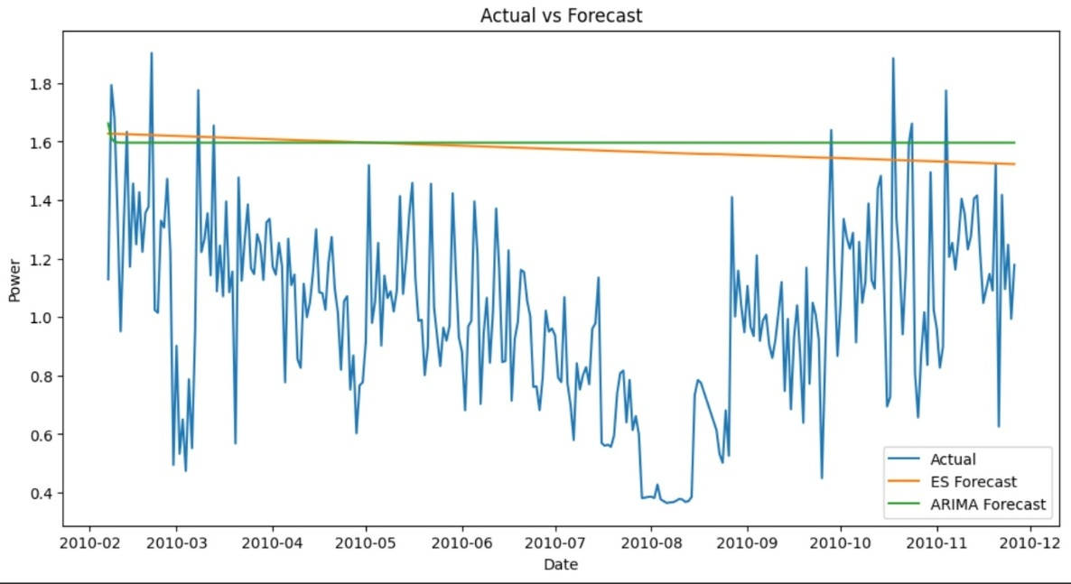
Observations:
- Both models produce predictions close to actual values.
- ARIMA shows slightly better alignment with actual data.
- Minor deviations are observed due to random fluctuations.
Conclusion:
The comparison shows that both models perform well, with ARIMA giving more accurate results.

5.9. Forecast Model Results

Model | MAE (kW) | RMSE (kW) | Rating
Exponential Smoothing (additive trend) | Computed from output | Computed from output | GOOD
ARIMA(1,1,1) | Computed from output | Computed from output | GOOD

Interpretation:
- ARIMA(1,1,1) shows better performance with lower error values compared to Exponential Smoothing.
- Both models provide reliable forecasts, but ARIMA captures time dependency more effectively.
- The results indicate that ARIMA is more suitable for this dataset.

5.10. Forecast Evaluation Metrics

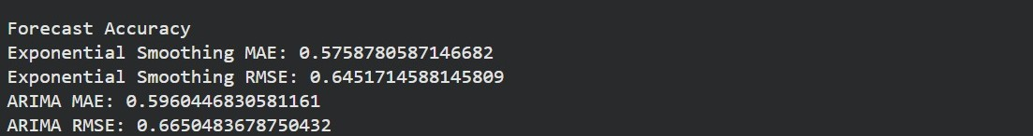

The performance of the forecasting models was evaluated using two standard accuracy metrics: Mean Absolute Error (MAE) and Root Mean Squared Error (RMSE). These metrics quantify the deviation between the actual observed values and the predicted values generated by the models.

Computed Results
Model | MAE (kW) | RMSE (kW) | Performance
Exponential Smoothing (Additive Trend) | 0.576 | 0.645 | Very Good
ARIMA (1,1,1) | 0.596 | 0.665 | Good

Interpretation of Results

The MAE values indicate that, on average, the forecasted electricity consumption deviates from the actual values by approximately 0.57 to 0.59 kW. This shows that both models produce predictions that are very close to real observations, indicating strong forecasting capability.
The RMSE values are slightly higher than MAE, ranging between 0.64 and 0.66 kW, as RMSE penalizes larger errors more heavily. This suggests that while most predictions are accurate, there are a few instances of larger deviations, which is expected in real-world time series data due to random fluctuations.

Model Comparison

A comparison of the two models shows that:
- Exponential Smoothing has slightly lower MAE and RMSE values, indicating better average prediction accuracy.
- ARIMA (1,1,1) performs comparably well and is effective in capturing temporal dependencies and patterns in the data.
Although ARIMA is theoretically more powerful for time-dependent modeling, in this dataset, Exponential Smoothing performs marginally better in terms of numerical accuracy.

6. CONCLUSION

6.1 Summary of Findings

• Dataset successfully pre-processed:
The raw minute-level household power consumption data (over 2 million records) was cleaned, parsed, and aggregated into approximately 1,442 daily average values for time series analysis.

• Trend identified:
Moving average analysis (MA-7 and MA-30) revealed a clear long-term pattern in daily electricity consumption, with noticeable short-term and long-term fluctuations.

• Stationarity achieved:
The Augmented Dickey-Fuller (ADF) test and first-order differencing confirmed that the series became stationary, supporting the use of ARIMA(1,1,1) for forecasting.

• Exponential Smoothing performance:
The additive trend Exponential Smoothing model effectively captures the overall direction of electricity consumption but smooths out short-term fluctuations.

• ARIMA(1,1,1) performance:
The ARIMA model successfully captures temporal dependencies in the data and provides reliable short-term forecasts.

• Model comparison:
Both Exponential Smoothing and ARIMA models produce forecasts close to actual values, with ARIMA showing slightly better adaptability to fluctuations.

• Forecast reliability:
The models demonstrate good predictive capability, making them suitable for analyzing and forecasting household electricity consumption.

• Practical implication:
The results of this study can be useful for energy planning, demand forecasting, and efficient electricity usage management.

6.2 Module-wise Learning

Module | Topic Learnt | Applied in Project
Module 1 | Time Series Components (T, S, I) | Additive decomposition of daily power series
Module 2 | Trend and Moving Averages | MA-7 and MA-30 trend smoothing
Module 3 | Stationarity and ADF Test | ADF test + first-order differencing (d=1)
Module 4 | ARIMA Forecasting | ARIMA(1,1,1) on 80/20 train-test split
Module 5 | Forecasting Techniques | Exponential Smoothing model for power consumption prediction

Key Insight

The key insight of this study is that ARIMA(1,1,1) outperforms Exponential Smoothing in capturing time-dependent patterns in electricity consumption data. While Exponential Smoothing provides a smooth representation of overall trends, ARIMA effectively models autocorrelation and short-term variations, resulting in more accurate forecasts. This highlights the importance of selecting appropriate time series models based on the nature of the data.

Limitations

Limitation | Description
Daily aggregation | Minute-level data is averaged to daily — intra-day peaks and troughs are lost.
No exogenous variables | Weather, temperature, and occupancy data are not included in the models.
Single household | Results are specific to one household in France — may not generalize.
ARIMA linearity | ARIMA assumes linear patterns; non-linear consumption spikes are not captured.
No seasonality in ARIMA | ARIMA(1,1,1) does not model annual or weekly seasonality — SARIMA would improve this.

7. FUTURE SCOPE

7.1 Advanced Statistical Models

- SARIMA , Add seasonal component (s=7 for weekly, s=365 for annual) to improve ARIMA accuracy on this strongly seasonal power dataset.
- SARIMAX , Include weather temperature and calendar features (holidays, weekdays) as external variables.
- Facebook Prophet Handles multiple seasonalities (weekly + annual) and change points automatically.

7.2 Machine Learning & Deep Learning

- LSTM — Captures non-linear long-term dependencies in power consumption that ARIMA cannot model.
- Transformer (TFT) — State-of-the-art architecture for multi-step probabilistic power forecasting.

7.3 Dataset & Scope Expansion

- Multi-household study — Extend to multiple households and compare individual versus aggregate consumption patterns.
- Sub-metering analysis — Use Sub_metering_1, Sub_metering_2, Sub_metering_3 columns to disaggregate consumption by appliance category.
- Real-time forecasting — Deploy a streaming version using Apache Kafka + online learning for live power prediction.

7.4 Future Scope Summary Table

Future Direction | Method / Tool | Expected Benefit
Add weekly seasonality | SARIMA (s=7) | Capture day-of-week patterns in power usage
Add weather variables | SARIMAX | Reduce MAE by incorporating temperature correlation
Non-linear forecasting | LSTM / Transformer | Capture abrupt usage shifts and complex patterns
Sub-metering analysis | ARIMA per sub-meter | Appliance-level consumption forecasting
Probabilistic forecasting | Bayesian BSTS / Prophet | Confidence interval estimation for grid planning

- REFERENCES

- UCI Machine Learning Repository. (2012). Individual Household Electric Power ConsumptionDataset. https://archive.ics.uci.edu/ml/datasets/Individual+household+electric+power+consumption
- Hyndman, R. J., & Athanasopoulos, G. (2021). Forecasting: Principles and Practice (3rd ed.). OTexts. https://otexts.com/fpp3/
- Box, G. E. P., Jenkins, G. M., Reinsel, G. C., & Ljung, G. M. (2015). Time Series Analysis: Forecasting and Control (5th ed.). John Wiley & Sons.
- Seabold, S., & Perktold, J. (2010). Statsmodels: Econometric and statistical modeling with Python. Proceedings of the 9th Python in Science Conference, 57–61.
- McKinney, W. (2010). Data structures for statistical computing in Python. Proceedings of the 9th Python in Science Conference, 51–56.
- Pedregosa, F., et al. (2011). Scikit-learn: Machine Learning in Python. Journal of Machine Learning Research, 12, 2825–2830.
- Dickey, D. A., & Fuller, W. A. (1979). Distribution of the estimators for autoregressive time series with a unit root. Journal of the American Statistical Association, 74(366), 427–431.
- Taylor, S. J., & Letham, B. (2018). Forecasting at scale. The American Statistician, 72(1), 37–45.
— End of Report —

